|  |
| --- |
| **Modeling COVID-19 Spread and Management: Incorporating Age, Social Distancing, Mortality, and Hospitalization in a Network-Based Simulation Approach**  Nick Fiorovanti1, Alexander Wang1  1 School of Biomedical Engineering, Drexel University, USA  Course : BMES678  Instructor: Ahmet Sacan  Date : 2023-06-08  Original Paper : Hou C, Chen J, Zhou Y, Hua L, Yuan J, He S, Guo Y, Zhang S, Jia Q, Zhao C, Zhang J, Xu G, Jia E. The effectiveness of quarantine of Wuhan city against the Corona Virus Disease 2019 (COVID-19): A well-mixed SEIR model analysis. J Med Virol. 2020 Jul;92(7):841-848. doi: 10.1002/jmv.25827. Epub 2020 Apr 25. PMID: 32243599. |

**abstract**

Understanding the dynamics of epidemic spread is crucial for the implementation of effective public health measures. Particularly, quantifying the impact of quarantine - a common countermeasure - on disease progression can provide valuable insights to guide public health policies. Through the implementation of a network model, we demonstrate that institutions of varying degrees of quarantining can not only decrease the proportions of exposure and susceptibility to the pathogen COVID-19, but extinguish infection faster.

# introduction

The role of quarantine in controlling the spread of infectious diseases has been well established since antiquity, with its utilization gaining prominence in recent pandemics [2]. It is a critical public health measure to mitigate and suppress disease transmission, but despite this widespread recognition, the actual quantifiable impact of quarantine on key epidemiological parameters remains an area requiring in-depth exploration. The necessity of such an examination has become more prominent today than ever, given the global interconnectedness that exacerbates the risk and speed of disease spread.

Guided by the framework provided in a pivotal study that investigated the transmission dynamics of COVID-19, our research extends the analysis of the quarantine impact by adopting a comprehensive parametric approach to analyze how varying degrees of quarantine influence key epidemiological outcomes across distinct stages in the disease lifecycle [1].

Drawing on the population categorization used in the original study (SEIR: Susceptible, Exposed, Infected, Diseased, Hospitalized, and Recovered), we examine how changes in the quarantine rate affect the peak proportion and the time to peak within each group. Our study thereby offers a more granular and dynamic understanding of how quarantine measures can shape the trajectory of an epidemic or a pandemic in the format of a network model.

The significance of our work lies in its potential to inform public health policy decisions in the face of infectious disease outbreaks. By providing a clear and robust analysis of quarantine impacts on disease dynamics, our findings aim to guide strategies that optimally balance disease control, societal functioning, and resource allocation, contributing valuable insights to the global fight against epidemics or pandemics.

Physiology:

The SARS-CoV-2 virus, responsible for COVID-19, primarily spreads via respiratory droplets when a person is in close contact with someone who has the virus. The virus enters the body through the nose and mouth, often when a person breathes in droplets produced by the exhaling of an infected person; coughs, sneezes, and breathing to name a few [3].

Once inside the body, the virus binds to cells in the respiratory system using the ACE2 receptor which allows the virus to enter and take over the cell, using the cell's machinery to reproduce and spread [4]. As the virus spreads, it can cause symptoms from mild (fever, cough, fatigue) to severe (difficulty breathing, chest pain). In severe cases, COVID-19 can lead to pneumonia, acute respiratory distress syndrome (ARDS), and death.

Goals:

By first utilizing the SEIR Ordinary Differential Equation model (ODE) model provided by Hou et al., we establish the granular representation of the disease propagation as simulated for Wuhan. In the second phase of our project, we deploy a network model to expand the SEIR model from the basic homogeneous mixing assumption to consider the heterogeneous interactions within a population. This model integrates several bountiful accessories such as levels of susceptibility and age-related mortality. Finally, with parametric analyses, we aim to explore and understand the impact of different quarantine rates on the progression of the COVID-19 pandemic by adjusting the quarantine parameter across simulations. Hopefully, we seek to investigate system responses to the array of quarantine rates to identify critical rates of dramatic changes, which could provide insight on expectations for quarantine policies to control a similar pathogen to spread.

A survey of other studies engendered suggestions of methodology and inspirations for our network implementation. Maheshwari’s network model presents interactions among individuals and impacts of social distancing measures [5]. Chang et al. incorporated dynamic mobility networks into a SEIR model to highlight superspreaders, which implied higher infection rates among disadvantaged demographics [6]. So et al.’s application of network analysis to visualize the pandemic risk based on regional connectedness provided a distinct approach that supplements modeling techniques [7].

# SEIR Model: Methods and Results

First, the well-mixed “susceptible exposed infectious recovered” (SEIR) compartmental model from Hou et al. was replicated to establish a basis for the foundational dynamics of COVID-19 transmission. This was done using MATLAB, which is a programming application and environment. The model utilizes four differential equations to approximate the change in susceptible, exposed, infected, and recovered individuals. These equations are provided below respectively representing the change in susceptible, exposed, infected, and recovered individuals over time:



$\frac{dS}{dt}= -\frac{r_{1}*β_{1}*I*S}{N}-\frac{r_{2}*β_{2}*E*S}{N}$

$\frac{dE}{dt}=\frac{r_{1}*β*I*S}{N}-α*E+\frac{r_{2}*β_{2}*E*S}{N}$

$\frac{dI}{dt}=α*E-γ*I$

$\frac{dR}{dt}=γ*I$

|  |  |  |
| --- | --- | --- |
| Symbol | Name | Value |
| N | Number of Individuals | $$11081000$$ |
| S | Initial Susceptible | 11080778 |
| E | Initial Exposed | 193 |
| I | Initial Infected | 27 |
| R | Initial Recovered | 2 |
| $$r_{1}$$ | Exposure Rate of Susceptible to Infected | 6 |
| $r_{2}$ | Exposure Rate of Susceptible to Latent | 6:1:18 |
| $${*β}_{1}$$ | Infection Probability When in Contact with Infected Individual | 0.04 |
| $${*β}_{2}$$ | Infection Probability When in Contact with Exposed Individual | 0.02 |
| $$α$$ | Rate of Exposed to Infected Conversion | 0.14 |
| $$γ$$ | Rate of Recovery | 0.048 |

**Table 1.** **List of Parameters Used in the Hou et al. Model.** This table displays the parameter symbols, names, and values used to replicate the SEIR results from Hou et al. *These parameters were not represented properly in the original publication of the SEIR model, thus they may differ from what is shown in the literature.

By creating a MATLAB function called basic_model.m, it was possible to implement the differential equations with constants from Hou et al. as provided in **Table 1** such that the system of differential equations was able to be utilized in coordination with MATLAB’s ode45() differential solver function to approximate the time course of the virus transmission in project.mlx. The model was simulated over 365 days to generate the SEIR results shown in **Figure 1**. The simulations show that most of the population starts out as susceptible then slowly people get exposed and infected. Over time, these infected individuals build up antibodies allowing for them to recover and become immune, as suggested where antibodies remain active for 500 days [8].

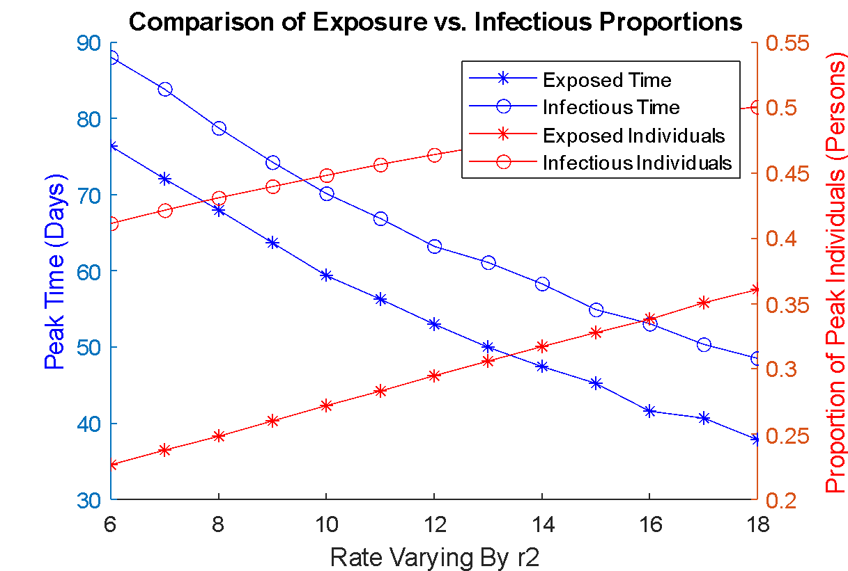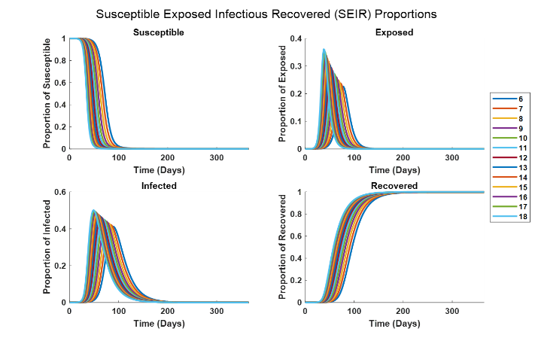**Figure 1. Proportions of ode45() Approximated Susceptible, Exposed, Infectious, and Recovered Individuals.** The results in this figure show the replicated SEIR model in MATLAB over 365 days (12 months) varied by the contact rate ($r_{2}$) .

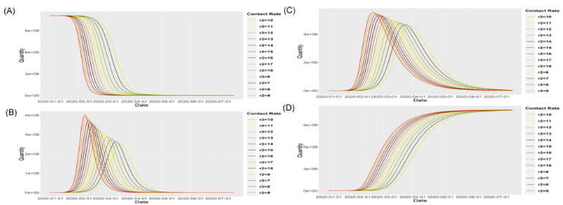The simulated results shown in **Figure 1** are meant to replicate the 6-month results from the publication by Hou et al. as shown in **Figure 2**. The numbers of individuals over time were divided by the total number of individuals to calculate proportions of each group over the course of a year to compare with the secondary network model, which utilized fewer individuals.

**Figure 2. SEIR Results from Hou et al.** Figure 2 in *The effectiveness of quarantine of Wuhan city against the Corona Virus Disease 2019 (COVID-19): A well-mixed SEIR model analysis* shows the parametric analysis for the SEIR model with respect to the contact rate ($r_{2}$) over 6 months.

In addition to approximating the number of individuals in each group for constant inputs, a parametric analysis was performed where the exposure rate of susceptible individuals to exposed individuals ($r_{2}$) was varied to suggest varying trends of transmission based on presumed contact between individuals. The maximum proportion of individuals in each group as well as the time in which the peak exposure or infection occurred were plotted. These metrics were chosen as the exposed and infected individuals make up the majority of the transmission population, resulting in initial susceptibility of an estimated 100% and ending recovery of approximately 100%. **Figure 3** shows that, by varying the rate of contact between susceptible and exposed individuals, the maximum proportion of individuals in each group as well as the time it takes for the groups to become fully established change. As the rate of contact increases, the proportion of infected individuals increases approximately 5% while the exposed individuals increase about 10%. Furthermore, the time which it takes to reach the peak individuals in each group is 45 days less as you go from the lowest rate to the highest contact rate.

**Figure 3. Parametric Analysis of Infected and Exposed Proportions with Respect to Contact Rate.** Proportions of both exposed and infectious individuals increase with higher contact rates, resulting in lower times to maximum individuals within these groups.

# Network Model: Methods and Results

The second model was also made using MATLAB. Numerous internal functions were used to create a symmetric contact matrix of 100 individuals, randomizing which of them were initially susceptible or infected. Numerous programming utilities like *for loops* and *if/elseif* conditions were then used to iterate over each day and each person in the contact matrix. As each individual and his or her contacts were evaluated, random numbers between 0 and 1 were generated to determine, based on the thresholds provided in **Table 2**, whether they fell above or below certain probabilities for exposure, infection, recovery, hospitalization, social distancing, and mortality. Each person would then be evaluated against each criterion. First, if contacts within the network were within an infected individual, they would be evaluated on if social distancing occurred. This contact network is visualized in **Figure 4**. If distancing did not occur, then each contact would be evaluated for the risk of exposure to the infected individual. Each infected person would then be evaluated to determine if they were able to recover, remain infected, or become hospitalized the next day. If an infected individual became hospitalized, they could 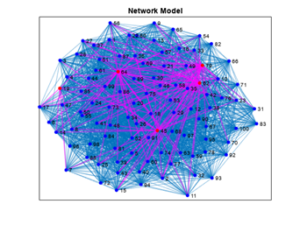theoretically recover, remain hospitalized, or pass away based on future iterations. Hospital, COVID-19 mortality rates were based on the age of the individual, which was also randomized for each person from 0-80. Finally, any susceptible individual was again evaluated on whether they maintained social distance, and if not, they became exposed. The proportions of each group were accumulated over the 365-day iterations, which were then repeated 100 times to calculate an average proportion of individuals over the time course of transmission as shown in **Figure 5**.

|  |  |  |
| --- | --- | --- |
| Symbol | Name | Value |
| N | Number of Individuals | $$100$$ |
| I | Initial Infected | 0.05 * N |
| S | Initial Susceptible | 0.95 * N |
| T | Simulation days | $$365$$ |
| R | Immune Individuals |  |
| H | Hospitalized Individuals |  |
| D | Deceased Individuals |  |
| ε | Exposure probability | $$0.05$$ |
| $β$ | Infection probability | $0.04$ [1] |
| $δ$ | Recovery probability | $$0.1$$ |
| $σ$ | Hospitalization rate | $0.15$ [12] |
| SD | Social distancing probabilities | $$0:0.1:1$$ |
| $D_29$ | Hospital death rate, age age≤29 | $$0.0043 [13]$$ |
| D_59 | Hospital death rate, 30 ≤ age ≤ 59 | 0.01 [13] |
| $D_+$ | Hospital death rate, age ≥ 60 | $$0.0257 [13]$$ |
| ρ | [D_29, D_59, D_+] |  |

**Table 2.** **List of parameters used in the network model.** The number of individuals was minimized to reduce computation time. 5% of the population was expected to be initially infected and 95% was susceptible. Probabilities for recovery and hospitalization as well as rates were determined from literature.

**Figure 4. Visual Representation of Contact Network.** The network model is contingent on individuals coming into contact with one another. This shows the extent to which each member of the network, denoted by a unique number, comes into contact with another individual, showing the extent of how transmission can affect a community. Red demonstrates an infected individual, and a purple line represents exposure.

**Figure 5. Average Proportion of Individuals Within Each Group Over Time Course of Viral Transmission.** The results in this figure demonstrate the contact network proportions with respect to a social distancing probability of 0.5. Over time, susceptible, exposed, infected, and hospitalized individuals dwindle while deceased and recovered proportions mark what remains after a year of COVID-19 transmissions.

In addition to the standard network simulation, a parametric analysis was performed to determine the effects of social distancing/isolating or quarantining while susceptible. These results are shown in **Figure 6** where the exposed and susceptible proportions seem to change the most over varying percentages of individuals quarantining while the times at which the proportions of both recovered and deceased individuals peak at the most varying times.

**Figure 6. Parametric Analysis of Quarantining Probabilities.** When investigating the probabilities used for determining whether an individual had isolated, the groups were able to be evaluated at both peak proportion of total individuals (left) and time to peak proportion (right).

Finally, the comparison between both contact network and SEIR models are shown in **Figure 7**.

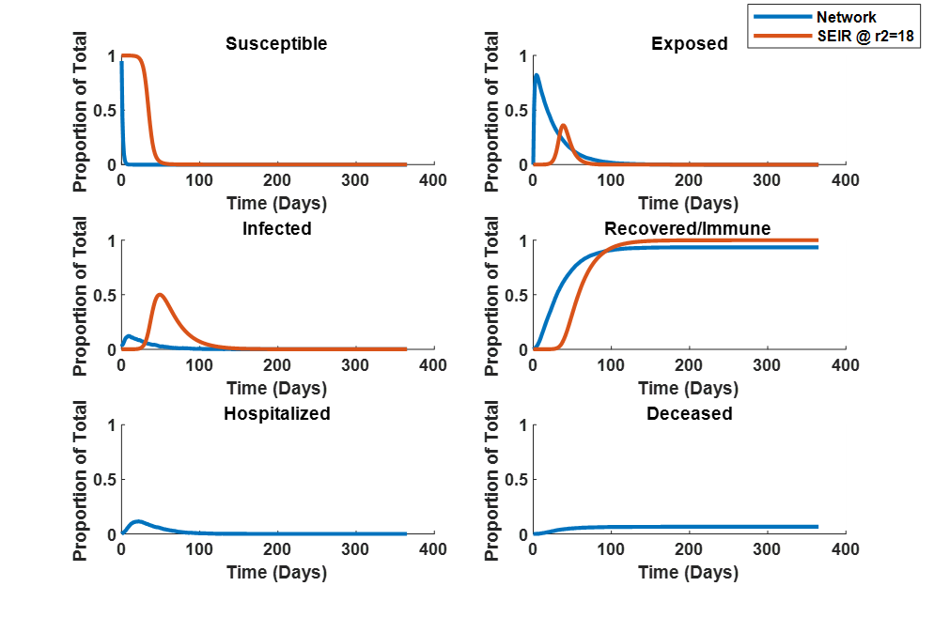

**Figure 7. Comparison of Network Model with SEIR Model Across Different Groups.** When the social distancing probability of the network model (SD) was 0.5 and the rate of the SEIR model for contact infection ($r_{2}$) was 18, the results were compared as shown, thereby suggesting that implementing hospitalization and mortality rates has significant impact on the susceptible, exposed, infected, and recovered proportion of individuals.

# DISCUSSION

The results of Hou et al.’s model fitting suggest that lowering the contact rate of latent individuals consistently reduces the number of infected individuals but may delay the peak in infections. Their curve estimations were in good agreement with reported cases [9, 10, 11]. Our work parallels the objectives of Hua et al. by leveraging the SEIR model as a foundation for understanding the transmission dynamics of COVID-19. However, we expanded on this model by considering the heterogeneity of population interactions using a network model. Moreover, we went further in exploring the impact of quarantine rates through parametric analyses. These enhancements are stepping-stones to manifesting more nuanced insights into the disease’s progression and the effectiveness of intervention measures and policy.

The conclusions drawn by Hua et al. are in line with our findings, particularly in terms of the critical role of contact rates. We observed similar dynamics in our model - the maximum proportion of infected and exposed individuals and the time it takes for these groups to become fully established change based on varying rates of contact. **Figure 7** demonstrates that the network model suppresses exposure and infected proportions substantially while concurrently preserving consistent percentages of recovered/immune individuals. The comparisons to susceptible and infected demonstrate superior control via the network, revealing how quarantining can transition to a steady state with infractions minimized to 0 while curtailing disease transmission. Moreover, **Figure 6** also highlights the effectiveness of social distancing and isolation in controlling the spread of the disease. The linear increase of maximum susceptible individuals and decrease of maximum exposure alongside the consistent time at peaks across the quarantining probabilities demonstrates its mechanism to approach the steady state.

Our advancements, while promising, also introduce several limitations and areas of further refinement. By introducing a network model to capture the heterogeneity of population interactions, we inherently increase the complexity of the model because of the sensitivity to the parameters we selected, such as the pattern of social contacts. Parametric analysis also operates under the assumptions about disease transmission and population behavior, to which we choose to be static and not dynamic.

There are still ways to improve these models for more granular dynamics and resolutions. Like in Chang and So et al., we could incorporate spatial dynamics into the model to account for geographical differences in infection rates to understand the impact of regional and habitat disparities on disease spread. Additionally, we could investigate potential application of our parametric analysis for other behavioral factors and characteristics of the population, such as compliance with public health measures. Finally, we could also integrate more real-time data into the model; as the pandemic evolves, so too does understanding of the virus and its transmission dynamics. Therefore, being able to regularly update the model with the most recent data could improve the accuracy of predictions and the effectiveness of interventions.

# References

1. Hou C, Chen J, Zhou Y, Hua L, Yuan J, He S, Guo Y, Zhang S, Jia Q, Zhao C, Zhang J, Xu G, Jia E. The effectiveness of quarantine of Wuhan city against the Corona Virus Disease 2019 (COVID-19): A well-mixed SEIR model analysis. J Med Virol. 2020 Jul;92(7):841-848. doi: 10.1002/jmv.25827. Epub 2020 Apr 25. PMID: 32243599.

2. E. Tognotti. Emerging Infectious Diseases. Emerging Infectious Diseases Vol. 19, No. 2. 2013. DOI: <http://dx.doi.org/10.3201/eid1902.120312>

3. Wiersinga, W.J., Rhodes, A., Cheng, A.C., Peacock, S.J., Prescott, H.C., 2020. Pathophysiology, Transmission, Diagnosis, and Treatment of Coronavirus Disease 2019 (COVID-19). JAMA 324, 782.. <https://doi.org/10.1001/jama.2020.12839>

4. Hoffmann, M., Kleine-Weber, H., Schroeder, S., Krüger, N., Herrler, T., Erichsen, S., Schiergens, T.S., Herrler, G., Wu, N.-H., Nitsche, A., Müller, M.A., Drosten, C., Pöhlmann, S., 2020. SARS-CoV-2 Cell Entry Depends on ACE2 and TMPRSS2 and Is Blocked by a Clinically Proven Protease Inhibitor. Cell 181, 271–280.e8.. <https://doi.org/10.1016/j.cell.2020.02.052>

5. Maheshwari, P., Albert, R., 2020. Network model and analysis of the spread of Covid-19 with social distancing. Applied Network Science 5.. https://doi.org/10.1007/s41109-020-00344-5

6. Chang, S., Pierson, E., Koh, P.W., Gerardin, J., Redbird, B., Grusky, D., Leskovec, J., 2021. Mobility network models of COVID-19 explain inequities and inform reopening. Nature 589, 82–87.. https://doi.org/10.1038/s41586-020-2923-3

7. So, Mike KP, et al. "Visualizing COVID-19 pandemic risk through network connectedness." *International Journal of Infectious Diseases* 96 (2020): 558-561.

8. Sherrell, Z. (2022, November 29). *How long do COVID-19 antibodies stay in the body?* https://www.medicalnewstoday.com/articles/how-long-do-covid-antibodies-stay-in-your-system

9. Health Commission of Hubei Province. http://wjw.hubei.gov.cn/bmdt/ ztzl/fkxxgzbdgrfyyq/.

10. National Health Commission of the People's Republic of China. <http://www.nhc.gov.cn/xcs/xxgzbd/gzbd_index.shtml>

11. Novel Coronavirus—China, disease outbreak news: Update. [https://www.who.int/csr/don/12‐january‐2020‐novel‐coronavirus‐china/en/](https://www.who.int/csr/don/12%E2%80%90january%E2%80%902020%E2%80%90novel%E2%80%90coronavirus%E2%80%90china/en/). Accessed 16 February 2020.

12. COVID-19 Hospitalization. (2023). https://=gis.cdc.gov/grasp/COVIDNet/COVID19_3.html

13. *COVID-19 Hospital Data - In-hospital mortality among confirmed COVID-19 encounters by week*. (2023). https://www.cdc.gov/nchs/covid19/nhcs/hospital-mortality-by-week.htm